*Resume Writing* is a two to four hour course designed to help you craft a resume for a 21st century job search. You will learn how to use computer resources to write, format, and distribute a resume that accurately reflects their skills, experience, and educational background.

*Learning Goals:*

* Use computer resources to create, format, and distribute a complete resume that accurately represents your skills, experience, and educational background

What is a resume?

Who needs a resume?

Why is a resume important?

How have resumes changed with technology?

What makes a “good” resume?

How long does an employer typically look at a resume?

***Anatomy of a Resume***

A resume usually has 5 Sections:

**SECTION 1:** Contact Information

|  |  |
| --- | --- |
| **[FIRST NAME] [LAST-NAME]** [Permanent Address]  [Phone number]  [E-mail] | Don’t use an email account with a silly name. You want potential employers to take you seriously, and an unprofessional email address will give them a negative first impression. Which email addresses are more professional? |

hawtlegggs59@hotmail.com

chunkymonkey240@yahoo.com

iHatework@aol.com

agnes.alderman@gmail.com

cbloomis@gmail.com

Miguel.A.Guzman@gmail.com

**SECTION 2:** Professional Summary and Career Objective

There are two common approaches to writing a professional summary. The first way is a short paragraph. Here is a professional summary for a retail manager:

**Professional Summary:**

Experienced, resourceful and effective retail manager with proven proficiency in all aspects of boutique management. Cutting-edge merchandiser with expert ability in combining innovative display techniques with visual standards and sales strategies in order to achieve optimal retail success. Top-selling sales associate who regularly exceeds client expectations by building on-going quality relationships.

A paragraph format professional summary has these features:

An alternate approach is to use a bulleted list to present your professional summary:

**Career Profile**

* Caring, compassionate Registered Nurse with seven years experience in private practice, hospital, and hospice environments
* Experienced Charge Nurse for cardiac and oncology floors for major teaching hospital
* Strong analytical skills, capable of assessing conditions and implementing appropriate intervention
* Effective trainer and educator for both peers and patients

A bulleted list professional summary has these features:

Finally, some people may still prefer to use an old-fashioned career objective:

**Objective:**

To contribute acquired bookkeeping and office management skills to an organization offering opportunities for advancement.

Why do you think employers prefer professional summaries?

Which format will you use? Why?

**SECTION 3**: Work History

The work history section is where you describe your previous employment experience in detail. This section should include:

**WORK HISTORY:**

**Previous/Current Employer Names**  
Dates worked (optional)   
Locations  
Job Titles  
Responsibilities, skills gained, achievements

There are two different work history formats: Chronological and Functional.

**Chronological Format**

May 2010 to present **Texas State Library** Austin, TX

**Library Assistant**

Assist patrons with research questions and locate resources. Catalog materials in database. Plan community literacy outreach programs.

June 2008 to March 2010 **Java-va-voom Coffee** Austin, TX

**Barista**

Prepared food and beverage orders and served customers. Developed customer relationships. Performed accurate cash handling functions.

**Functional Format**

**Communications:** Executed international public relations campaigns. Represented department in meetings. Prepared annual reports.  
 **Customer Service:** Handled customer concerns and complaints. Resolved high volume of weekly customer inquiries. Expertly sliced pastrami according to customer preference.  
  
**Present:** Maddox Consulting Nome, AL**Vice President  
  
Past:** O’ Flannery and Sons Imports Mobile, AL  
   **Communications Director**                          Joe’s Deli Hackensack, NJ**Cured Meat Engineer**

Who should use the chronological format and why?

Who should use the functional format and why?

**SECTION 4**: Educational Background

Most jobs have an education requirement, ranging from a high school diploma to very specific industry certifications. In the Educational Background section you list where you went to school, degrees you have earned, notable academic accomplishments, and industry-related certifications. Typically, the educational background includes the following:

**EDUCATION:**

**School Name,** Location

**Degree Earned,** Major, Graduation Date

GPA (if higher than 3.0)

Honors, Accomplishments, Relevant Coursework (optional)

What should you consider when listing your educational background?

**SECTION 5:** Other Skills, Non-Work Experience

If you have other relevant skills not mentioned in other parts of your resume, you can list them in this section.

*Other Skills Examples:*

Some employers look for employees who have a well-rounded life *outside* of the workplace. By describing volunteer and other non-work experience, a potential employer can see that you are serious about developing skills and are motivated by something besides a paycheck. Furthermore, people without an extensive work history can use this section to show that they still have useful skills not reflected in their employment history.

*Non-Work Experience Examples:*

***7.0.2 Chronological Resume Example***

|  |  |  |  |  |
| --- | --- | --- | --- | --- |
| **MARIA GARCIA**  228 Excalibur Lane, Round Rock, TX•512-555-2222•mariagarcia2788@gmail.com | | | | |
|  | | | | |
|  | | | | |
| **Career Objective**  To provide effective and engaging computer training for adults.  **Professional Summary**  Compassionate and caring instructor with a goal of providing effective and engaging computer training for adults. Detailed and organized with materials and processes while innovate and creative in the instructional process. | | | | |
| **Work Experience** | | | | |
| 2009-Present | | Waterloo Industries | Round Rock, TX | |
| **Technology Trainer**   * Trained over 80 staff on Microsoft Office applications * Modified and created training curricula to target company needs * Served as Help Desk support for Microsoft Office applications | | | | |
|  | | | | |
| 2007-2009 | | Round Rock ISD | Round Rock, TX | |
| **Technology Teacher Aide**   * Assisted teacher with computer skills classes in secondary settings (6-12th grade) * Worked one on one with students as necessary | | | | |
| **Education** | | | | |
| 2011-2015 | Austin Community College | | | Austin, TX | |
| **AAS in Office Administration** | | | | |
| **Other Skills/Experience** | | | | |
| * Certified Microsoft Office Instructor * Bilingual English and Spanish | | | | |

***7.0.3 Functional Resume Example***

**MARVIN GARCIA**

20 Oak Springs Road, Great Falls, TX 78223 [marvin.humberto.garcia@gmail.com](mailto:marvin.humberto.garcia@gmail.com)

**QUALIFICATIONS**

* Has 5 years of welding in the creation, installation, and repair of commercial equipment
* Managed and trained a group of 8 junior welders
* Recognized for expertise in managing welding projects that meet specifications for quality, deadline, and and budget
* Knowledgeable of SMAW, FCAW, and GMAW processes
* Follows safety guidelines resulting in excellent safety record

**MANAGEMENT SKILLS**  *ADMINISTRATION*

* Trained more than 15 junior welders in assorted welding forms
* Troubleshooting of issues and potential issues saved approximately $20K
* Communicated with customers regarding orders, clarifications, and work guidelines

*TECHNICAL*

* Consistently welded 23% faster than average welders while meeting specifications
* Knowledgeable of SMAW, FCAW, and GMAW processes

*ORGANIZATION*

* Efficiently organizing welding work to maximize safety and quality while streamlining processes, which resulted in finishing orders with high standards under budget and before deadlines

**WORK HISTORY**

* Gamma Precision, Great Falls, MT Senior Welder
* ADF International, Great Falls, MT Welder
* Loenbro, INC, Great Falls, MT Junior Welder

**TRAINING**

* Awesome Falls College, Great Falls, AS
* Welding Certification, February 2011

**RESUME STRATEGIES**

**CONTENT** or “How to Write a Resume”

* Be concise
* Keywords
* Research
* Detail oriented
* Accuracy
* Audience
* Word choice/voice

**DESIGN** or “Make It Look Pretty”

* Bullet points
* White Space
* Alignment
* Font size and style
* Spelling
* Headers

**AVOID** or “Don’t Do This!”

* Lies
* Multiple fonts
* Pictures
* Overly personal information
* Salary
* Misspellings and other typos

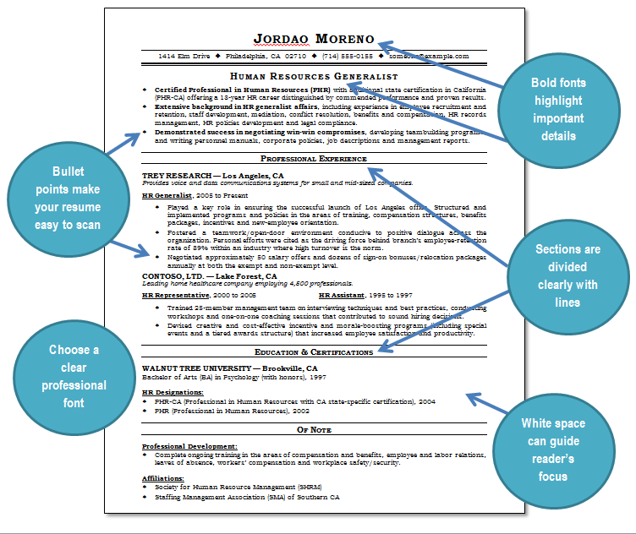***7.0.4 Resume Editing Activity***

**Directions:** The resume on the next page needs some serious editing. Locate the file ***- 7.0.4 Resume Editing Activity*** - in your student folder and open it. Follow the instructions below to correctly format the resume. When you are finished, the resume should fit on one page.

1. In the top section select the text “**Maria Garcia.**” Change it to **font size 22** and make it **bold** by clicking on the **bold icon.**
2. Select the **Career** **Objective** heading and change the text to **font size 14.**
3. Select the **Professional Experience** heading and change the font to Arial**.**
4. Select the **underlined text** in the Work Experience section and click on the **underline icon** to change it back to normal text.
5. Select the text in italics in the **Education** section and click on the **italic icon** to change it back to regular text.
6. **Delete** the picture.
7. Click on the **Review** tab and then the **Spell Check** button. Spell-check and **correct spelling errors.**
8. Use **File/Save As** to save the corrected document as Maria Garcia Corrected Resume in your student folder.

Hint: Use the 7.0.3 Chronological Resume Example in your Student Manual as a guideline for what your corrected resume should look like once you finish.

|  |  |  |  |  |
| --- | --- | --- | --- | --- |
| MARIA GARCIA  228 Excalibur Lane, Round Rock, TX•512-555-2222•mariagarcia2788@gmail.com | | | | |
|  | | | | |
| **Career Objective**  To provide effective and engaging computer training for adults.  **Professional Summary**  Compassionate and caring instructor with a goal of providing effective and engaging computer training for adults. Detailed and organized with materials and processes while innovate and creative in the instructional process. | | | | |
| **Work Experience** | | | | |
| 2009-Present | | Waterloo Industries | Round Rock, TX | |
| **Technology Trainer**   * Trained over 80 staff on Microsoft Office applications * Modified and created training curricula to target company needs * Served as Help Desk suport for Microsoft Office applications | | | | |
|  | | | | |
| 2007-2009 | | Round Rock, ISD | Round Rock, TX | |
| **Technology Teacher Aide**   * Assisted teacher with computer skills classes in secondary settings (6-12th grade) * Worked one on one with students as necessary | | | | |
| **Education** | | | | |
| 2011-2015 | Austin Community College | | | Austin, TX | |
| ***AAS in Office Administration*** | | | | |
| j0195384**Other Skills/Experience** | | | | |
| * Certified Microsoft Ofice Instructor * Bilingual English and Spanish | | | | |

***7.0.5 Resume Information Activity***

**Directions:** Fill out each section with the appropriate information. You can then use this worksheet as a reference when writing your resume.

**Personal Information**

|  |  |
| --- | --- |
| Full Name: |  |
| Address: |  |
| Telephone: |  |
| Email |  |

**Professional Summary**

List 3-4 of what you think your strongest skills are:

1.

2.

3.

4.

**Employment Experience.** List most recent employer first:

|  |  |  |
| --- | --- | --- |
| **Employer Name:** |  | Dates Employed  From:  To: |
| Location: |  | Position Title |
| Responsibilities: |  | |
| Accomplishments: |  | |
| **Employer Name:** |  | Dates Employed  From:  To: |
| Location: |  | Position Title |
| Responsibilities: |  | |
| Accomplishments: |  | |

|  |  |  |
| --- | --- | --- |
| **Employer Name:** |  | Dates Employed  From:  To: |
| Location: |  | Position Title |
| Responsibilities: |  | |
| Accomplishments: |  | |

**Educational Background**

|  |  |  |  |  |
| --- | --- | --- | --- | --- |
| **School Name:** |  | Dates Attended  From:  To: | | |
| Location: |  | Degree Or Certificate Earned: | | |
| Field Of Study |  | | Gpa |  |
| Honors, Relevant Coursework: |  | | | |
| **School Name:** |  | Dates Attended  From:  To: | | |
| Location: |  | Degree Or Certificate Earned: | | |
| Field Of Study |  | | Gpa |  |
| Honors, Relevant Coursework: |  | | | |

**Other Skills**

|  |  |
| --- | --- |
| Languages: |  |
| Computer Skills: |  |
| Other Skills: |  |

**Non-Work Experience**

|  |  |
| --- | --- |
| Volunteer Experience: |  |
| Awards: achievements: |  |
| Other: |  |

***7.0.6 Chronological Resume Template***

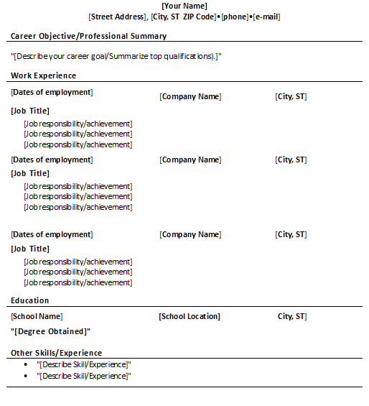

***7.0.7 Functional Resume Template***

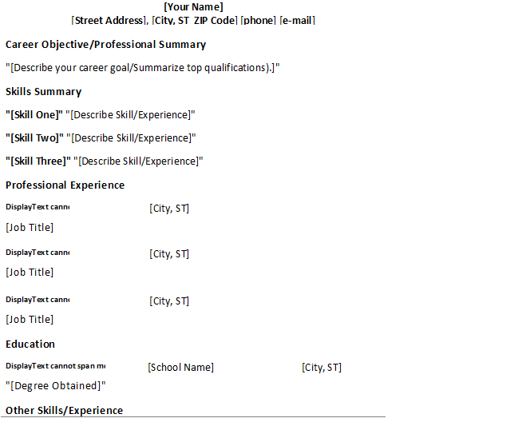

**21st CENTURY RESUMES -** Key functions in Microsoft Word

Formatting text (fonts, style, alignment, spacing)

Working with bullets

Spell check and thesaurus

Create a resume from a template

Many employers today prefer to receive resumes through email. What are different ways to send a resume via email?

As always, **you must protect yourself when you using the internet**. If you post a resume to a job site while you are currently employed, your boss might not be happy to discover that you are looking for another job. Also, not every job posting online comes from a reputable employer. What are ways you stay safe online?

***Resume Keywords***

It is crucial that your resume is targeted to the specific job you are seeking. By including the right **keywords** to describe your qualifications, you can show a potential employer that you already speak the “language” of the company. Today, many companies even use software to filter resumes based on a set of predetermined keywords. This means that if you know how to choose the correct keywords, your resume has a better chance of appearing at the top of the pile!

Below you can find a list of keywords divided by categories to help you get started. Remember, this is not a complete list, and every company has their own set of keywords. The best way to figure out what keywords you should use is to do your own research of the company.

|  |  |
| --- | --- |
| **MANAGEMENT AND LEADERSHIP**  Administer Assign  Authorize Decide  Delegate Develop  Direct Interview  Manage Meet  Organize Train  Supervise Strategize | **ADMINISTRATION**  Administer Allocate  Distribute Facilitate  Furnish Insure  Process Provide  Procure Purchase  Schedule Secure  Ship Supply |
| **COMMUNICATION**  Advocate Contact  Create Declare  Design Display  Negotiate Inform  Interpret Promote  Publicize Sponsor  Represent Recruit  Write | **PLANNING AND RESEARCH**  Analyze Compile  Develop Evaluate  Gather Identify  Implement Investigate  Measure Prepare  Plan Progress  Solve Structure  Submit |

## 

***Resume Terminology***

Career Objective: a one sentence statement of a job seeker’s employment goals. The career objective is typically located after the contact information section on a resume. Most hiring managers now prefer professional summaries instead of career objectives.

Chronological Format: work history organized in sequential order with employment dates listed, starting with the most recent position. The chronological format is ideal for job seekers with a continuous work history.

Educational Background: resume section where educational qualifications and professional certifications are listed.

Functional Format: work history that highlights skills first and positions titles second with employment dates omitted. This format is suited for older job seekers, people with long gaps in their work history, and inexperienced workers.

Keywords: targeted words or phrases that effectively describe a job applicant’s skills and experience. Hiring managers scan resumes for certain keywords to find qualified applicants.

Plain Text Format: a resume that does not have any special text formatting such as bold fonts or bullet points. Plain text formatted resumes are often needed for online job applications.

Professional Summary: resume section that succinctly illustrates an applicant’s most notable accomplishments, skills, and experience. The professional summary can be written as a paragraph or a bulleted list. It is sometimes called a *career profile*.

Resume: a short one to two page document that summarizes one’s experience, skills, and accomplishments.

Work History: resume section that lists one’s employment experience. Each section of work history should have: job titles, company names, locations, and experience gained. Two common work history formats are the *functional format* and the *chronological format*.